Sprint 20 RETRO – Balloon (15-7-2019)
Risks for the project
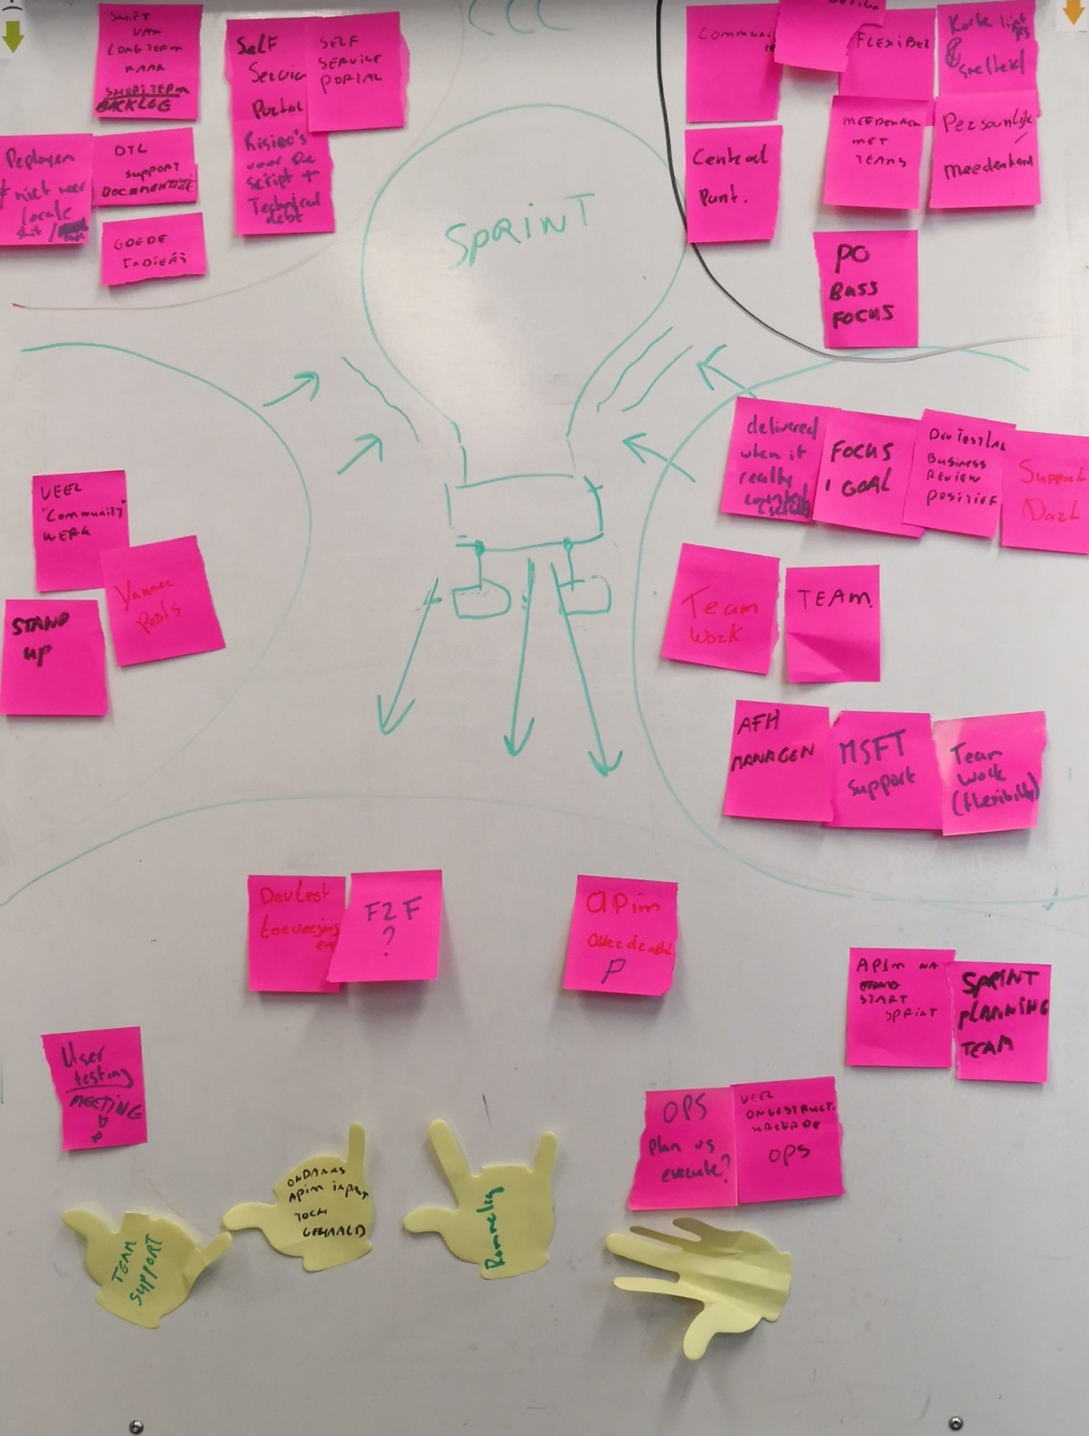
What slowed us down
Our feeling of the sprint
What made this sprint a success

weqqw
Our vision for the project
Based on: https://www.funretrospectives.com/hot-air-balloon-bad-weather/

SPRINT (..-20xx)
Sprint activities

Our feeling of the sprint process | …  ACTION ITEMS:  - ..
What made this sprint a success | …  ACTION ITEMS:  - ..
What slowed us down | …  ACTION ITEMS:  - ..
Risks for the project | …  ACTION ITEMS:  - ..
Our vision for the project | …  ACTION ITEMS:  - ..

